Writing Practice Stations Handout Name:_____________________________________________ Per_______

Station 1–Annotating Text:
Read the directions at this station and use the provided article to fill out the table below.
Main Ideas  (be as specific as possible – one word is not enough) | Supporting Evidence | Do YOU agree or disagree that the main ideas are supported? Explain.

Station2—Identifying Evidence:
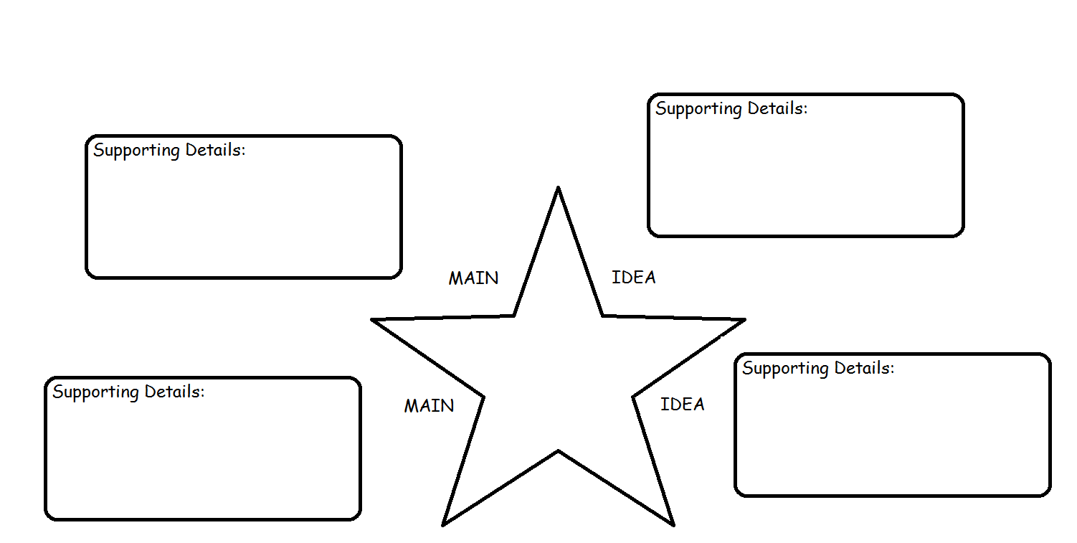
Read the directions at this station and use the provided article to fill out the table below.

Station 3—Citing Evidence:
Read the text provided and fill out the following sections below. Be sure to include the proper Bibliography form in the Citation section. Use Easy Bib or the other sources provided to accomplish this task.

Main Ideas | Supporting details | Citations (use Easy Bib or Citation Nation website)

Station 4--Plagiarism Activities 1:
1.________ 2.________ 3.________ 4.________ 5.________ 6.________ 7._________

Situation A:

_________________________________________________________________________________________________________________________

Situation B:

Watch the videos provided on the iPads provided. When finished, answer the question below:

What are the three types of plagiarism? Explain each one on the lines below.

_________________________________________________________________________________________________________________________

_________________________________________________________________________________________________________________________

____________________________________________________________________________________________________________________________________________________________________________________________________________________________________________________________________________________________________________________________________________________________________________________________________________________________________________________________________________________________________
Station 5—Plagiarism Activities 2:
Citation 1:

_________________________________________________________________________________________________________________________

_________________________________________________________________________________________________________________________

Citation 2:
_________________________________________________________________________________________________________________________

_________________________________________________________________________________________________________________________

Station 6—Plagiarism Activities 3:
Underline and Properly Cite the following text:

Greek Myths: Reveling Ancient Lives
Learning about ancient cultures can be difficult because so many of the buildings, artifacts and writings have been lost in the centuries since their societies flourished. In the case of the Ancient Greeks, archeologists and historians have tools such as temples, statues, coins, artwork and some writings to help them reconstruct the past. They can also use the stories told by the Greeks, which are mythological, may reveal how they viewed their world and the ways in which they constructed their society. For example, historians know that the original Greek gods, the Titans, were said to have brought into being by Gaia and Uranus. The Titans were personified forms of natural forces. It is possible that associating the gods, who ruled the earth, with nature shows how much control natural exerted over the Greeks. Additional, the stories of the Titans’ fall from the power reveals Grecian preoccupation with the inevitability of fate, which controls and directs all lives and events. This, too, suggest that the Greeks may have felt like they were at the mercy of forces larger than themselves and that they little personal control over their lives. Historians also note another theme that repeats itself in the Greek stories of the Titans: the violent power struggles that results in the overthrow of the ruling gods by their children. This they speculate, may mirror real-life situations when foreign invaders attempted to impose or integrate their own culture onto the cultures into the existing Greek ways. Although myths are only stores, they may reveal more about the way people thought and lived than would be apparent at first glance. For this reason, they are worth further study.

Station 7—Paper Format:

OUTLINE WORKSHOP
Write your notes about each section in the space below each section of the Paper Format Sheet.
INTRODUCTION

BACKGROUND

SUPPORTING EVIDENCE #1

SUPPORTING EVIDENCE #2

SUPPORTING EVIDENCE #3

COUNTERARGUMENT

SUM UP CONCLUSION ♣ Sum up claim + supporting evidence statements

SO WHAT CONCLUSION

